2015 Fall Bible Conference
Bible Chapel of Delhi Hills

Theme: “Progressive Sanctification and Our Identity in Christ”

Speaker: Bruce Ware

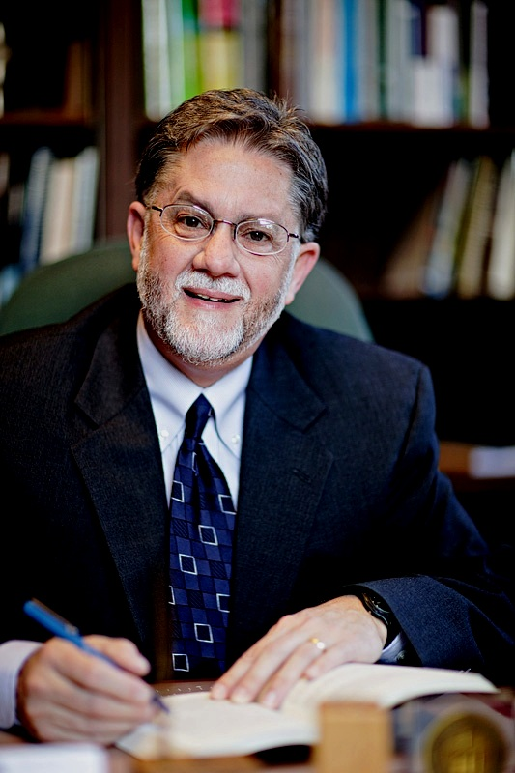

Our speaker for this year’s conference is Bruce Ware. Since 1998 he has served at The Southern Baptist Theological Seminary in Louisville, KY where he is the T. Rupert and Lucille Coleman Professor of Christian Theology, and chairman of the Department of Christian Theology. Bruce and his wife of 37 years, Jodi, love drives in the country, hikes in the woods, walks on the beach, time with their two daughters and
three grandchildren, along with reading books and listening to good music.

Dates and Times: October 16-18th
Session 1 Friday 7:00 pm
Session 2 Saturday 4:00 pm; Dinner 5:30 pm (Call for details)
Session 3 Saturday 6:30 pm
Session 4 Sunday 9:30 am
Session 5 Sunday 10:30 am
Session 6 Sunday 6:00 pm

Where: Bible Chapel of Delhi Hills
705 Pontius Road Cincinnati, Ohio 45233
(513) 941-4707 bcdelhi.com biblechapel@fuse.net

The church is located on Pontius Road ¼ mile south of the Rapid Run Middle School and across from Story Woods Park.
A love offering will be taken for our speaker.

